Name: ______________________________________ Guided Notes #1: Order of Operations

Level 1 Notes: What are the Order of Operations

Simplification:

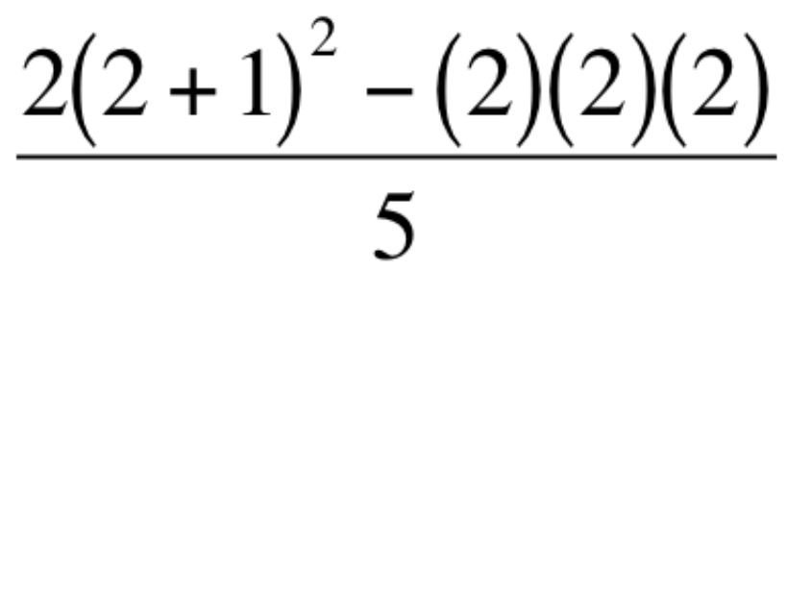

You tell John he owes you $50. He gives you:

1 ten, 17 ones, 24 quarters, 30 dimes, 400 penies.

You have 3,000 songs on your ipod but you feel like listening to Kanye’s “Flashing Lights”.

How are you going to find the song?

Do you always follow the order of operations?

Level 2 Notes: Simplifying with the Order of Operations

Evaluate: STEPS:



Evaluate:



Level 2 Notes: Guided Practice

1.)  2.) 

3.)  4.) 

Level 2 Notes: Independent Practice

1.)  2.) 

3.)  4.) 

Level 3 Notes: Let’s Make a Gallery

1.)  2.) 

3.)  4.) 

5.)  6.) 